Resources you will need:

Make sure you are on the JUN_A branch, **but we will not be changing, saving, or pushing anything.**

Windchill for access to:

1. Part number drawings
2. ECOs/MCOs
3. Rule sheets
4. Revision structure tab of parts

TKAT in order to:

1. Confirm a test plan has been made or is absent
2. Upload the VT package of the model you’re reviewing
3. Confirm that the test plan works

DevOps query and repo searching may also be needed for investigating more information about a model, if you need to.

**To have all the information you would need to perform model review, I go ahead and do this before you start:**

* **Open the model Configit, look at its Revision Letter. That is the revision that you will use for everything else**
* **The part drawing PDF, checkfile of its latest ECO/MCO for the model, rule sheet document if it’s not in the checkfile, and the Windchill structure tab to compare part revisions**
* **Two TKAT tabs open, one with the Test Plan editing page and test running page.**

I will also provide an explanation behind each of the columns within the excel for clarity's sake below.

**General Information:**

Summary/Additional Notes:

* Use this box to write anything that might not be covered in the excel sheet columns, as well as to highlight the main points of the models’ errors.

Date Reviewed:

* Just write down the date that you reviewed the model. JUN_A is expected to continue to have new ECOs/MCOs during our work so it could help us to better understand a model’s timeline by the time we need to make changes to it.

Configit Revision Letter:

* write down the revision letter of the model that you see in the Configit program. Even if it’s wrong, we need that information to better understand when that model was last updated.

Date when the model’s changes were last pushed (MM/DD/YYYY):

* You can probably ignore this one for the most part. It was used to understand which models haven’t been touched in a while.

ECO/MCO the model was last changed under:

* Sometimes the model was last changed under the ECO/MCO that its latest revision was assigned under. However, sometimes that model has been changed under a different ECO/MCO, when one of the team members noticed corrections needed to be made to it. You may need to check the Repo for dates of model changes

**Configit and Part Drawing BOM Comparison Section:**

How many items in the BOM?:

* We’re looking for the number of items specifically on the drawing’s BOM, and not the number of child parts. This is because some models may have several V part numbers and it could be a hassle to try to find and count them all, especially if the V part number rule has changed over time.
* 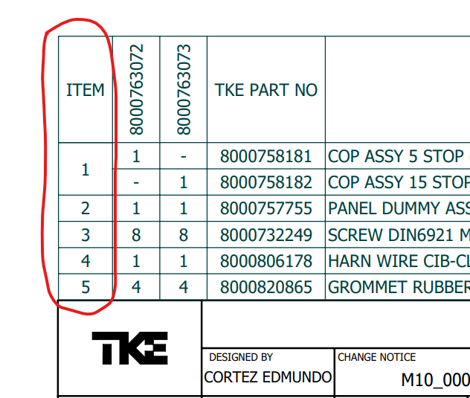

Does the model structure match the BOM drawing of the same revision letter?

* Look at the model in Configit and look at the BOM of the part drawing. Confirm that all the parts are present in the model (including V part numbers), that their DESC, PARTNUM, and QTY values are correct, and that their ITEM numbers are correct. Make sure parts with design sheet notes or MFG data sheet notes have their rules. Check to see if the rules written in Configit match with the Rule documents. If ANY of these are wrong, please write “No.”

If not, what are some differences between the model and its drawing?

* This is a follow-up question to the previous one. Please write out all the errors and mistakes that you found here.

**Configit Model Section:**

Does the model have static groups when it should?

* Older models in Configit may be missing their non-configurable child parts. Please write “No” if you see that the model in Configit is missing any of their child parts that you saw in the part drawing’s BOM.

Does this model have DA properties?

* Check to see if the master group has information in its “AssemblyFile” and “ExportType” properties. If anything is there, please write “Yes”.
* A screenshot of a computer

  AI-generated content may be incorrect.
* A child group may also have DA information as well. Please write down if you see it in the Summary/Additional Notes section are the beginning of the excel document. It’s extra important to make a note if it has =”” in those spaces:
* A screenshot of a computer

  AI-generated content may be incorrect.

Does the model have JSME in its rules?

* Check all the parts and if any of them have JSME rules made in their groups, please write “Yes”.
* The parent group and its children may not have JSME, but it’s possible that the grandchildren or great-grandchildren do. If that is the case, then make a note of it in the “Summary/Additional Notes” at the beginning.

Does the model use FloorMatrix?

* If you see FloorMatrix in the model, write Yes.

Does the model use ForEach?

* Check all the parts and see if any of them have information in their “ForEach” properties sections. If you see anything in that section, write “Yes”
* A screenshot of a computer

  AI-generated content may be incorrect.

Does the Model use a Helper Parameter?

* Check the master group of the model. If you see a Parameter such as DOORCONFIG, WALLCONFIG, HNDRLCONFIG, RLBKCONFIG, etc. in there and it looks like this, then write Yes
* A screenshot of a computer

  AI-generated content may be incorrect.

Notate any modeling errors noticed in Configit:

* Basically, check everything in the model to make sure it’s all correct. All parts should be present. All the Group Properties and Variable properties in the models should be correct. Rules should be the same as the R-document’s rules. If any of these (or anything else you might find) is wrong, make a note of it.

How hard is the solution to the modeling errors?

* Basically, explain what would need to be done to fix the errors you found in the model in Configit. If something like a part description is wrong, that would be a quick fix to make. However, if it were something like a JSME rule is incorrect, that could more time to rewrite and test.

Did the model compile without an issue?

* Compile the model by clicking the 2 Green Arrow button, write down any error you might see in the console:
* A screenshot of a computer

  AI-generated content may be incorrect.
* If you see any errors, select “No”

If you said No, what were the compile errors?

* Read the compiling error in the console and summarize what it said. For instance, the above picture’s error was because of “Missing Parameters.GRSECTYP”

Even with the compile errors, create a VT package of the model. It will be used for the next section.

**TKAT Testing Section:**

Does it have a test plan made for its model revision?

* You should look on the test plan page of TKAT and search for the model number. If there is a test plan present that has the same revision letter of model’s revision letter in Configit, select “Yes”. Otherwise, select no.

Did the test plan pass?

* Upload the VT package you just made and run the test with the test plan of the same revision letter. Make sure the test found all parts, their part quantities, and their rules. Everything should match. Be especially careful if you see VERIFY, and double check everything is there. Just to be safe, you should still check even if the results come back with “Pass”. If everything looks correct, write “Yes”.
* If there was no test case with the same revision letter as the model to test, write NA

If not, try an earlier test plan to see if the model passes that. Which revision was it? (DNE if none)

* If the test plan of the same revision letter failed, then try a test plan with an earlier revision letter. Type the revision letter of that backup test plan in this section.
* If you didn’t need to use a backup test plan because the first one passed, just write “NA”.
* “DNE” means “Does Not Exist”. If there is no other test plan for the model in TKAT, you can write DNE.

Did that earlier revision test plan pass?

* Make the same checks as before in the “Did the test plan pass?” question. Write Yes if everything is correct.

Were part(s) missing in the test plan?

* Look at both the test results and the test plan itself. Make sure both have all the parts as the BOM, including non-configurable (static) parts.
* If no test plan was ever made, write NA.

Did TKAT Response show an error?

* Look at the “JSME Debugs” menu. If there is anything other than the following picture, then select Yes for this section.
* A screenshot of a computer

  AI-generated content may be incorrect.

If so, what kind of error did the TKAT response say? You can also include why the TP failed here.

* Write some of what the response said, such as any errors it may say.
* If the test plan failed, you can write why it failed here too. (Ex: output values not matching, missing parts, quantities not matching, etc.)